INFOSYS VIRTUAL INTERNSHIP 6.0

FOOD TRENDS UNDERSTANDING CUSTOMER PREFERENCES

BATCH: 11
TEAM: C

SUBMITTED TO: NITHYASRI J
START DATE: 29-12-2025

TEAM MEMBERS:
Vaishnavi Shah
Sam Joseph
Raghav Vyas
Piyush Nitnaware
HARINI M

CONTENT :
1. Project Title
2.Project Objective
3. Project description
3.1 Overview
3.2 Project Approach
3.3 Technology Used
3.4 Insights from the Dashboard
3.5 Real-World Impact for Media and Public Communication
4. Timeline Overview
5a. Key Milestones
5b. Project execution details
6. Snapshots / Screenshots
7. Challenges Faced
8. Learnings & Skills Acquired
8.1. Technical Skills
8.2. Analytical and Problem-Solving Skills
8.3. Soft Skills and Team Collaboration
8.4. Domain Knowledge and Application
9. Testimonials from team
10. Conclusion
11. Acknowledgements

1. Project Title
Infosys_FoodTrends: Understanding Customer Preferences
The project titled Infosys_FoodTrends: Understanding Customer Preferences focuses on analyzing food and restaurant industry data to identify meaningful trends related to customer behavior, cuisine demand, pricing strategies, and service availability. The project uses data analytics and visualization techniques to convert large datasets into insightful dashboards that support informed decision-making.
Important points:
- Focus on food and restaurant industry analytics
- Emphasis on customer preferences and engagement
- Implemented using business intelligence tools

2. Project Objective
The primary objective of this project is to analyze restaurant data and derive insights that explain customer preferences and behavior. The project aims to understand how factors such as cuisine type, price range, online delivery, and customer engagement influence restaurant ratings and popularity. Another key objective is to present these insights in an interactive and visually appealing manner so that they can be easily interpreted by non-technical audiences, including media professionals and the general public.
Key objectives:
- Analyze customer preferences across different cuisines and regions
- Study customer engagement using ratings and vote counts
- Understand the impact of pricing on customer perception
- Communicate insights through interactive dashboards

3. Project Description
3.1 Overview
The Infosys Food Trends project was carried out as part of the Infosys Springboard Internship program and was executed as a team project involving five members. The dataset used for this project was sourced from Kaggle and contains detailed information about restaurants, including location, cuisine types, pricing, ratings, votes, and service availability. The project resulted in the development of seven interactive dashboards using Power BI, each designed to focus on a specific analytical dimension. Collectively, these dashboards provide a comprehensive understanding of food trends and customer preferences.
Overview highlights:
- Team-based project with five contributors
- Public dataset sourced from Kaggle
- Seven dashboards covering multiple analytical aspects
- Focus on real-world applicability

3.2 Project Approach
The project followed a well-defined and structured approach to ensure accuracy and quality. Initially, the dataset was collected from Kaggle and explored to understand its structure, attributes, and limitations. Data preprocessing was then carried out using Power Query to handle missing values, remove duplicates, and standardize categorical data. Additional calculated fields were created to support deeper analysis, such as price categories and engagement indicators. Once the data was cleaned and prepared, a data model was created in Power BI to establish proper relationships. The dashboard development phase involved selecting relevant KPIs, designing visuals, and adding slicers for interactivity. Throughout the project, dashboards were reviewed and refined through team discussions.
Approach summary:
- Dataset exploration and understanding
- Data cleaning and preprocessing
- Feature engineering and data modeling
- Dashboard creation and validation
- Continuous review and refinement

3.3 Technology Used
The project utilized Power BI as the primary visualization tool due to its ability to handle large datasets and create interactive dashboards. Power Query was used for data cleaning and transformation, ensuring the dataset was analysis-ready. DAX was applied to create calculated measures such as average ratings and vote-based metrics. Microsoft Excel was used for initial inspection and validation of the dataset before integration into Power BI.
Tools and technologies:
- Power BI for visualization and analytics
- Power Query for data preprocessing
- DAX for calculated measures
- Microsoft Excel for data validation

3.4 Insights from the Dashboard
The analysis provided several meaningful insights into customer behavior and restaurant performance. The dashboards revealed that restaurants are primarily concentrated in metropolitan areas, indicating higher demand in urban regions. Cuisine analysis showed that North Indian and Chinese cuisines dominate the market, reflecting widespread customer preference. Customer engagement was significantly higher for restaurants offering online delivery services. Pricing analysis revealed that restaurants in higher price ranges tend to receive better ratings, suggesting a perceived association between price and quality. Additionally, restaurants with higher vote counts displayed more stable ratings compared to those with fewer votes.
Major insights:
- Urban regions dominate restaurant presence
- Certain cuisines show consistently higher demand
- Online delivery boosts engagement
- Higher pricing correlates with better ratings
- Vote count impacts rating stability

3.5 Real-World Impact for Media and Public Communication
The findings of this project have strong relevance in real-world scenarios, particularly for media and public communication. Media organizations can use the insights to publish data-driven articles on food trends and customer preferences. Consumers can leverage the dashboards to make informed dining decisions. Restaurant owners and business stakeholders can use the analysis to improve service offerings, pricing strategies, and customer engagement. Overall, the project demonstrates how data visualization can effectively communicate complex information to diverse audiences.
Real-world impact:
- Supports data-driven media reporting
- Enhances public awareness of food trends
- Aids business strategy and decision-making
- Demonstrates effective visual storytelling

4. Timeline Overview
The project was completed over a total duration of forty days. The execution was divided into milestone-based phases, with each milestone allocated one week. This structured timeline ensured systematic progress, effective task distribution, and timely completion of deliverables.
Timeline highlights:
Week | Activities Planned | Activities Completed
1 | Dataset selection, understanding project requirements, and defining objectives | Selected Kaggle dataset, analyzed data structure, and finalized project objectives
2 | Data cleaning, preprocessing, and transformation | Cleaned dataset using Power BI Power Query, handled missing values, standardized columns
3 | Data modeling and creation of calculated measures | Established data relationships and created DAX measures for key metrics
4 | Design of core dashboards and KPI visuals | Developed KPI cards, bar charts, and slicers for overall performance analysis
5 | Customer and restaurant performance analysis | Built dashboards for customer behavior and restaurant-wise performance
6 | Food category and trend analysis | Analyzed popular cuisines, items, and ordering trends using time-based visuals
7 | Insight generation and dashboard optimization | Derived key insights, improved dashboard layout, and optimized visuals
8 | Final review and documentation | Validated results, prepared project report, and finalized dashboards

5. Project Execution
5a. Key Milestones
The first milestone focused on data collection and preprocessing to prepare the dataset for analysis. During the second milestone, the first three dashboards were developed, focusing on market presence, cuisine demand, and customer engagement. The third milestone involved completing five dashboards and refining previously developed dashboards. The final milestone was dedicated to completing all seven dashboards, validating insights, and optimizing performance.

Milestone Overview:
Milestones | Description | Date
Milestone 1 | Data Preparation & Transformation | 16-01-2026
Milestone 2 | Core Dashboard Development | 23-01-2026
Milestone 3 | Food & Category Trend Analysis | 30-01-2026
Milestone 4 | Strategic Insights & Optimization | 06-02-2026

Milestone summary:
Milestone 1: Data Preparation & Transformation
The first milestone focused on collecting and preparing the dataset for analysis. The dataset was sourced from Kaggle and contained restaurant, customer, order, and rating-related information. An initial exploration of the dataset was conducted to understand its structure, attributes, and data types.
Data cleaning was performed using Power BI Power Query, where missing values, inconsistent entries, and redundant records were identified and handled appropriately. Columns were standardized to maintain uniformity in formats such as categorical values, dates, and numerical fields. Unnecessary columns were removed to improve data model efficiency.
Additionally, calculated columns and DAX measures were created to support analytical requirements such as total revenue, order count, average ratings, and customer-related metrics. This milestone ensured that the dataset was accurate, consistent, and analysis-ready, forming a strong foundation for subsequent dashboard development.

Milestone 2: Core Dashboard Development
In the second milestone, the focus shifted to designing and developing the core dashboards in Power BI. A structured dashboard layout was planned to represent overall business performance, customer behavior, and restaurant performance in a clear and interactive manner.
Key visual elements such as KPI cards, bar charts, line charts, and slicers were implemented to present high-level metrics including revenue, total orders, customer count, and average ratings. Relationships between tables were verified to ensure accurate filtering and cross-visual interactions.
The dashboards were designed with usability in mind, enabling users to quickly interpret trends and compare performance across cities, restaurants, and time periods. This milestone resulted in functional dashboards that provided a comprehensive overview of the dataset.

Milestone 3: Food & Category Trend Analysis
The third milestone involved detailed analysis of food categories, popular items, and ordering patterns. Category-wise performance was examined to identify the most preferred cuisines and food items based on order frequency and customer ratings.
Trend analysis was conducted to study ordering behavior across different time periods, days, and customer segments. Visualizations were created to highlight variations in demand, peak ordering periods, and customer preferences. Rating trends were also analyzed to understand the relationship between food quality, consistency, and customer satisfaction.
This milestone helped uncover deeper insights into customer behavior and food trends, enabling a more granular understanding of what drives demand and performance in the restaurant ecosystem.

Milestone 4: Strategic Insights & Optimization
The final milestone focused on generating actionable insights and optimizing the dashboards for performance and clarity. Key insights related to restaurant consistency, quality stability, customer retention, and revenue concentration were derived from the analytical findings.
Dashboards were refined by optimizing visuals, reducing clutter, and improving interactivity through effective use of slicers and filters. Measures and calculations were validated to ensure accuracy and reliability of insights.
Finally, project documentation was prepared, summarizing the methodology, dashboards, challenges, and outcomes. This milestone ensured that the project delivered meaningful business insights and a polished analytical solution ready for evaluation and future enhancement.

5b. Project Execution Details
The project was executed collaboratively by a team of five members, with shared responsibilities across all phases. Team members contributed by creating dashboards, suggesting analytical ideas, aligning visuals, and validating insights. Regular discussions ensured consistency in design and accuracy in analysis. This collaborative approach significantly improved the overall quality of the project.
Execution highlights:
- Team-based collaboration
- Shared ownership of work
- Iterative improvement process
- Consistent design and analysis

6. Snapshots / Screenshots
This section contains screenshots of all seven dashboards developed during the project. The screenshots visually demonstrate the KPIs, filters, and insights derived from the analysis and support the findings discussed in this report.

Included dashboards:
  - Market Presence & Coverage
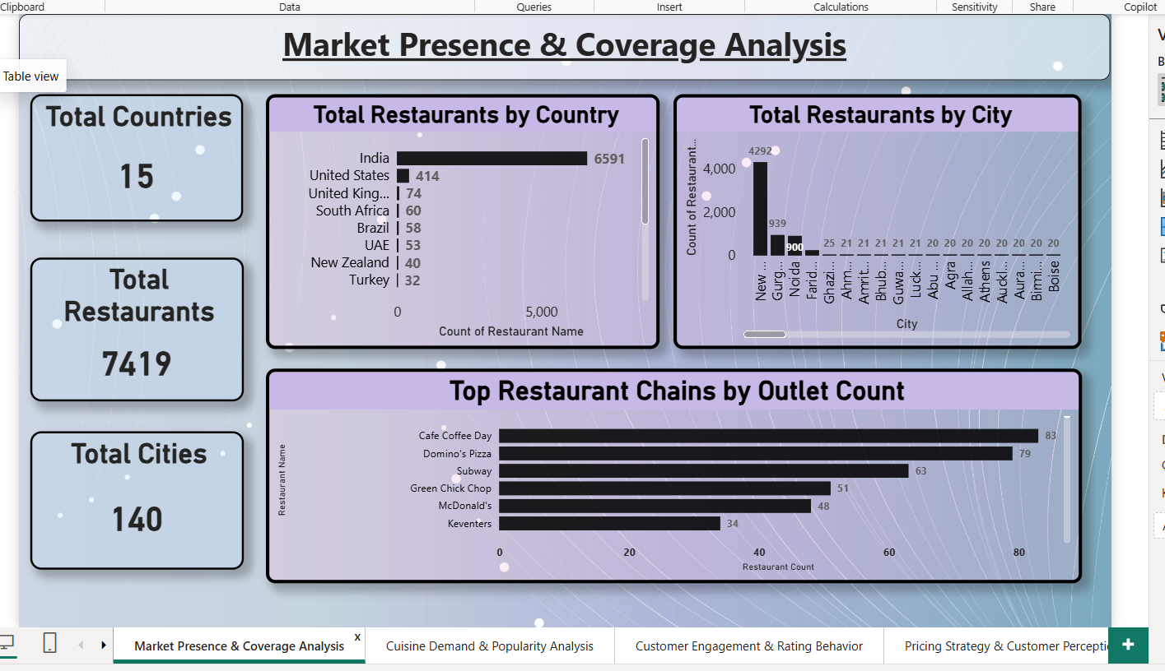

  - Cuisine Demand & Popularity
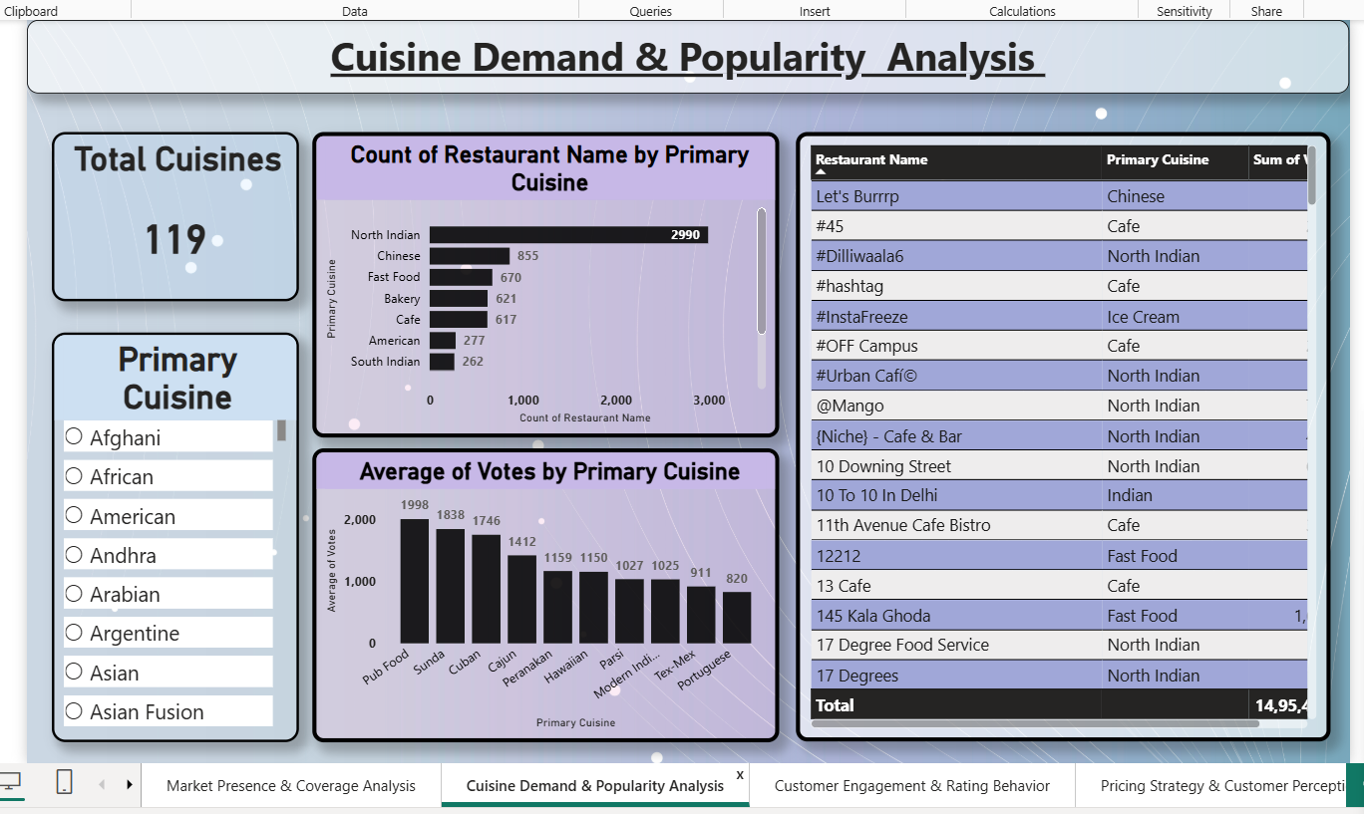

  - Customer Engagement & Ratings

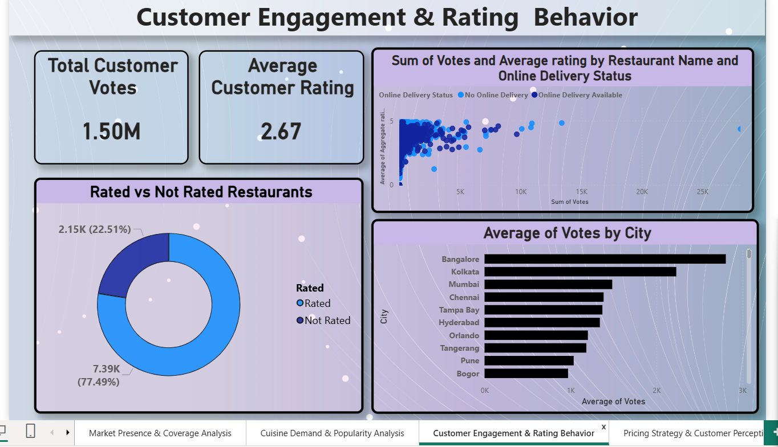

  - Pricing Strategy & Perception

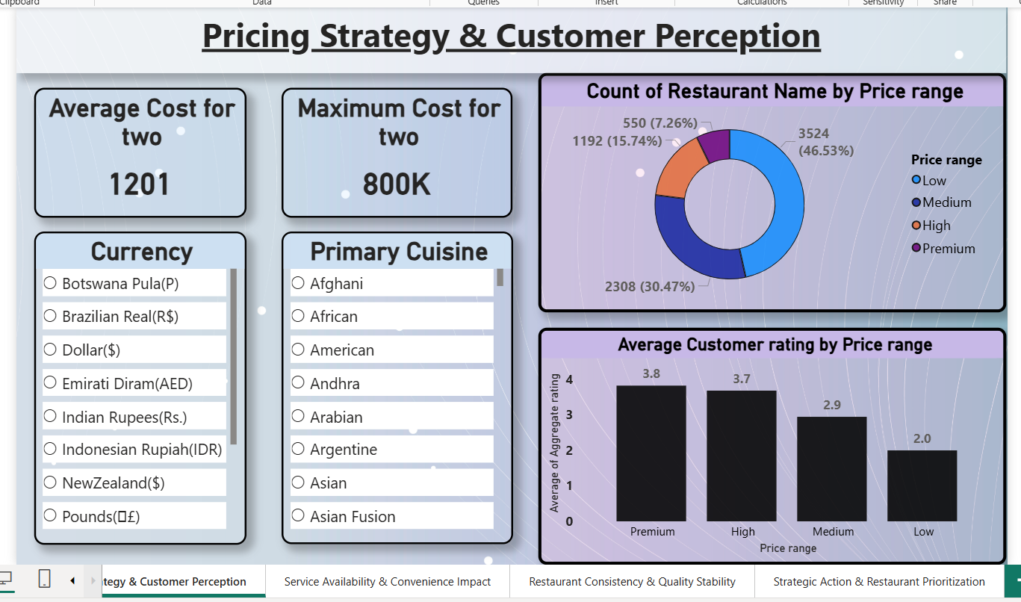

  - Service Availability Impact

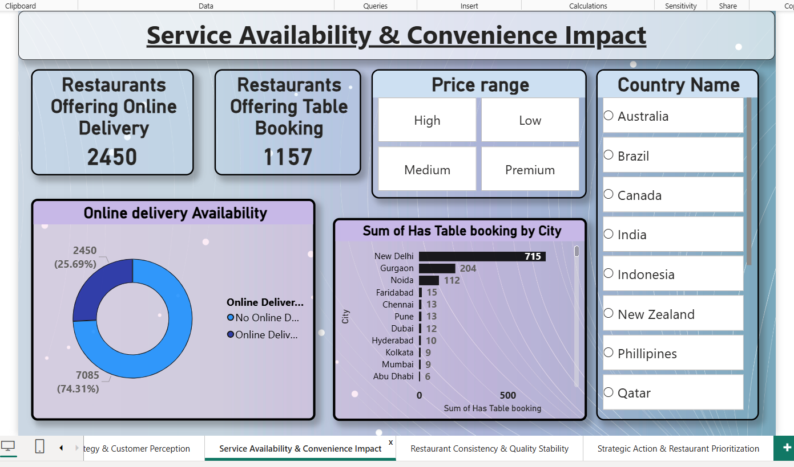

  - Quality Stability Analysis

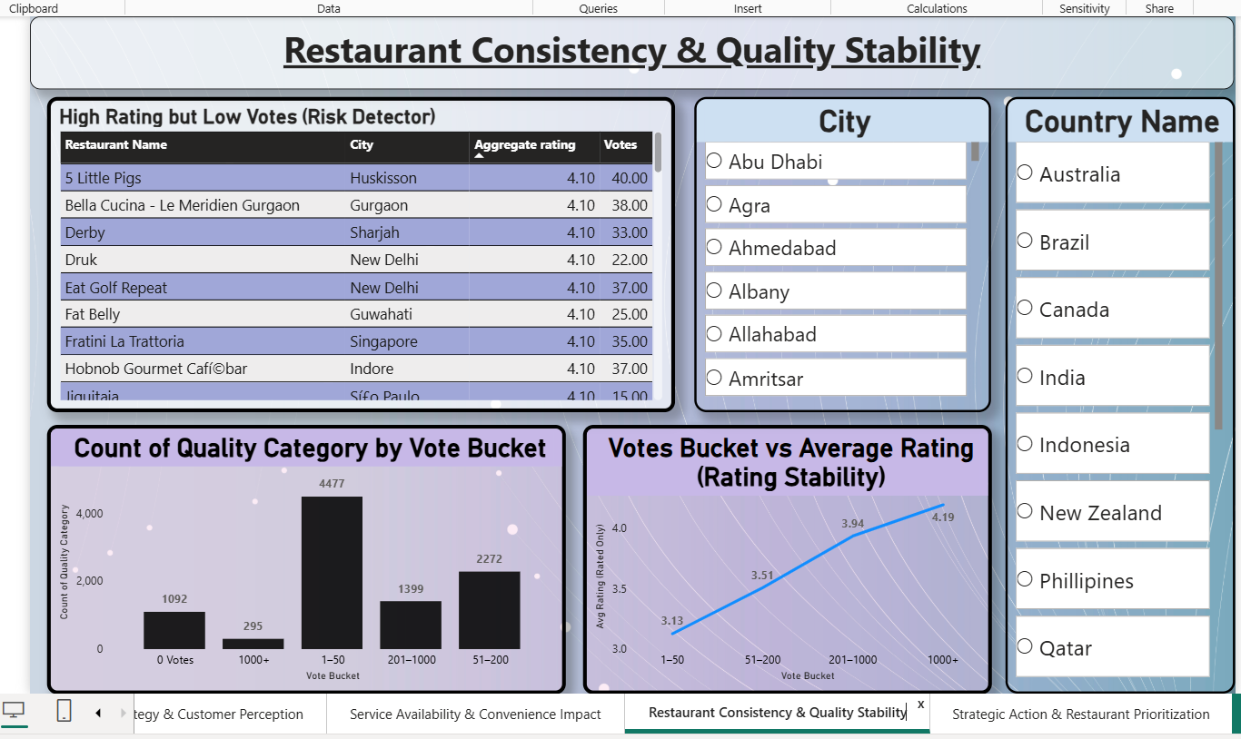
  - Strategic Restaurant Categorization

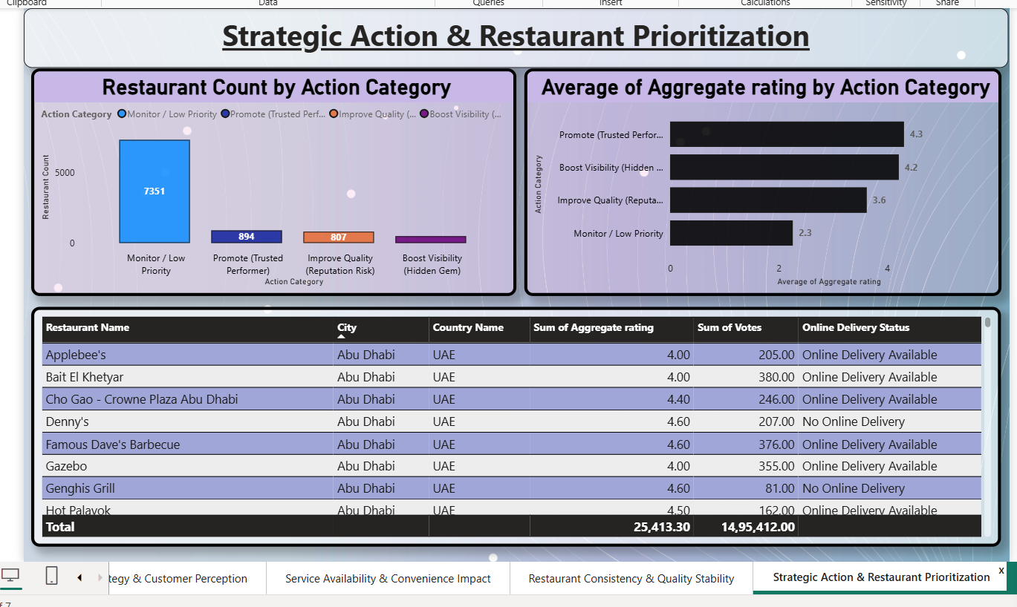

7. Challenges Faced
Several challenges were encountered during the project, including handling missing and inconsistent data, managing large datasets, and interpreting rating trends with low vote counts. These challenges were addressed through preprocessing techniques, optimization of visuals, and collaborative problem-solving.
Key challenges:
- Data quality issues
- Dashboard performance optimization
- Rating interpretation challenges
- Maintaining visual consistency

8. Learnings & Skills Acquired
8.1 Technical Skills
The project enhanced practical knowledge of Power BI, Power Query, DAX, and data modeling.
8.2 Analytical and Problem-Solving Skills
The project strengthened analytical thinking, KPI identification, and insight validation.
8.3 Soft Skills and Team Collaboration
The project improved communication, teamwork, and time management skills.
8.4 Domain Knowledge and Application
The project provided hands-on exposure to food industry analytics and customer behavior analysis.

9. Testimonials from Team
Team members expressed that the project provided valuable hands-on experience in data analytics and enhanced collaborative learning. The iterative review process and shared responsibilities were highlighted as major strengths.

10. Conclusion
The Infosys_FoodTrends project successfully demonstrates how data analytics and visualization techniques can be applied to understand customer preferences and restaurant performance. The project achieved its objectives by transforming raw data into actionable insights through seven comprehensive dashboards, making it a valuable learning experience during the Infosys Springboard Internship.

11. Acknowledgements
The team sincerely thanks Infosys Springboard for providing the opportunity to complete this internship. Special appreciation is extended to Ms. Nityasree for her guidance and support. The collaborative efforts of all team members contributed significantly to the successful completion of this project.

